TOC
Mall Sightings Page 2
Advent Tree-ditions Page 3
Ornament Scripture Connection Chart Page 6
Family Advent/Christmas Activities Page 7
Budget for Christmas Page 8
Christmas Stocking Tradition Page 8
Caroling Story Page 11
Ten Best Christmas Traditions for Family Bonding Page 12
Christmas Angel Finger Puppet Page 23
Keep Christ in Christmas Page 24

Article Links

When Christmas Invaded a war
https://inspiration.org/christian-articles/when-christmas-invaded-a-war/

Christmas PotPourri: Tips and Ideas to Welcome Guest
http://mtlmagazine.com/article/christmas-potpourri-a-collection-of-tips-and-treats-to-welcome-guests/

Mall Sightings
By Karen Whiting

Go shopping at the mall to find signs of Christmas related to Jesus.
The chart below gives symbols to find, and Bible verses to read and discuss as Christian signs of Christmas. See how many you can find.

When you find one, check it off, and mention to shop workers the reason for the symbol.

- Christmas Lights Jesus is the light of the world John 8:12
- Patient Customers Patience is a godly virtue 1 Corinthians 13:4
- Toy drives for the needy God wants us to be generous Matthew 25:35-40
- Christmas Trees We are part of God’s family tree Hosea 14:8b
- Nativity Set Jesus came Luke 2:1-7
- Candy Canes (Shepherd staffs) Shepherds worshipped Jesus Luke 2:8-20/John 10:11
- People expressing thanks God wants us to be thankful 1 Thessalonians 5:18
- People giving to the needy Giving is the Christmas spirit 2 Corinthians 9:7
- Someone helping another person Jesus wants us to serve others John 13:34
- Star decorations Wise men followed a star Matthew 2:9
- People from many nationalities Jesus came to save everyone John 3:16
- Wreath-circle of greens God’s love is like a circle-eternal 1 John 4:7-8
- Angels God’s messengers Luke 2:9-12
- Dove Sign of the Holy Spirit Matthew 3:16
- Sheep We are God’s sheep Luke 2:8
- Snowflakes God washes our sins white as snow Isaiah 1:18
- Crown Jesus is our king Matthew 2:2
- Gold, incense, or myrrh Gifts given Jesus Matthew 2:11
- People at peace God brings peace to believers Luke 2:14
- Carolers Singing praises God Isaiah 30:29

Tree-ditions
By Karen H Whiting
Walking toward the living room, I stopped in my tracks and listened to my children’s voices:
“It’s ruined now. Dad chopped off the best part!” Michael exclaimed.
“The top is still on, and it’s still tall.” James said.
“Look at it,” Michael urged, “Dad chopped off the bottom and the branches are too bushy. How can anything big fit under the tree now?”
Becky quietly stated, “Maybe we won’t get much this Christmas.”
Their words dispelled my dreams of the tree and decorations helping our children understand the meaning of Christmas. Our family had spent a cold, blustery Saturday in early December, seeking the perfect Christmas tree.
We trudged onward in the freezing Connecticut temperatures and biting winds, until we found a tall, perfectly shaped, blue spruce. My husband, Jim, lifted his ax and whacked at the trunk. It toppled onto the snowy ground. We proudly carried the tree home and stood it in the center of our living room. Now, I wondered, “What should we do with this tree, this spinner of materialistic dreams?”
I told Jim about the children’s comments, and we prayed, trusting the Creator of trees to direct us in the use of our Christmas tree. We searched the scriptures and discovered God’s word about an evergreen tree, in Hosea 14:8b, “... I am like an evergreen tree, yielding my fruit in you throughout the year. My mercies never fail.” [TLB] Here the evergreen tree is a symbol of God, the Father, caring for and blessing His children throughout the year.
However, we wanted to do more than point to the tree and say, this is a picture of God. The words inspired us to think about family trees and begin new traditions and create special activities for sharing the idea that we are part of God's family tree. We looked at our family genealogy, placed a nativity with the presents below the tree, and celebrated Christ while decorating the tree. The children still delighted in opening gifts, but they also focused more on Jesus with our tree-ditions.
Now, our Christmas tree serves as a reminder of the ever-growing family of God. He made everyone as unique and individual as the needles and branches of the tree. To show we are members of God’s family we hang photo ornaments on the tree.
We cut red and silver, foil paper stars and glue our photos in the center to remind us that we are shining lights for Christ. Each year we place a container filled with paper ornaments near the tree. The children invite visitors to write their names on the paper decorations and hang them on the tree, if they are Christians. Guests who are not Christians are told about Jesus and invited to become members of God’s family.
The analogy of the Christmas tree to our family tree led to another tradition. We hang a photo-genealogy tree on the wall to remember relatives who live far away. This became a way to celebrate new additions to the family, with adding new photos, and a focal point of discussing the arrival of each member.
Reminiscing about our wedding and the preparations made for each addition to the family brings a sense of unity. We talk about how each new person changed our lives. We reflect on births, and someone usually asks, “How could you not know about Darlene’s coming till she started kicking inside you, Mom?”
A discussion about Jesus flows from this conversation, centering on preparing for the celebration of the arrival of Jesus and how His birth changed the world and lives of many people.
Another tradition we started is placing a nativity at the foot of the tree, closer to the children’s eye level. After placing Jesus at the bottom of the tree, near the roots, we read, in Isaiah 11, where Jesus is the root of Jesse. We discuss how, through Him, the giver of living water, we receive eternal life. He gave God’s family eternal roots. When looking at wrapped packages our children also spot the figures of Mary, Joseph, and Jesus. Then they talk about Christmas as the birthday of Jesus.
Decorating our tree became a special occasion, celebrated with cookies and music. Friends are invited to join the event. We hang the lights on the tree, reminding us to share the light of Christ with others. As we decorate the tree with ornaments symbolizing spiritual fruits, gifts, and blessings from God, we read scriptures about each type of ornament.
As a reminder of the wisemen, a star is placed on top of the tree, where we learned new wisdom about God, and fulfilled our vision of celebrating Christ in Christmas.

As you deck the tree read scriptures matching the types of ornaments

Ornament Scripture Reason
Angels Luke 2:9,10 God’s messengers
Animals Romans 1:20 Creation witnesses to God
Birds Matthew 5:26 God cares for birds and us
Boots Romans 10:15 Feet that bring good news
Candles Luke 24:32 Hearts burning for God
Candy Canes John 10:11 Staff of Jesus, our shepherd
Dog Matthew 15:27-28 Faith
Dove Matthew 3:16 Symbol of Holy Spirit
Flowers Matthew 6:28-30 God provides our beauty
Fruits Galatians 5:22 Fruits of the Holy Spirit
Gingerbread/cookies 2 Corinthians 2:15 We are a fragrance for Christ
Hearts Matthew 22:37 Love God
Houses Matthew 22:39 Love your neighbors
Musical ornaments Psalm 150 Praise God
Nativity figures/manger Luke 2:7 Humility/family
People, carollers 2 Peter 3:9 Salvation is for all people
Popcorn strings Colossians 2:9-10 Developing as Christians
Rainbows/colored balls Genesis 9:16 God keeps His promises
Reindeer Psalm 42:1 Thirst for God
Ribbons/garlands Isaiah 61:1 Tied/bound with love
Sheep Luke 2:20; Psalm 23 We are His sheep
Snowflakes Isaiah 1:18 Purity/forgiveness
Soldiers 2 Timothy 2:3 Soldiers of the Lord
Star Matthew 2:2,9-10 Star that guided wisemen
Stockings Acts 13:52 Be filled with joy/Holy Spirit
Strings of lights Matthew 5:14-16 We are lights shining for God
Tiny gifts John 3:16 The gift of Life
Tree top light John 8:12 Jesus is light of the world
Vehicles Matthew 28:19 Great commission
Wreaths 1 John 4:7-8 Circle of love
Wisemen Matthew 2:1,11 Wise people praise God

Budget for Christmas
It’s almost the most wonderful time of the year! It’s almost the most stressful time of the year, too! It follows a time of thanking God and thinking of your blessings, so before shopping, be thankful for your budget, large or tiny.
It’s important to balance reality of your finances with hopes and dreams of an extravagant holiday. Overspending could produce a stressful New Year, so be realistic.
Stay on budget
If you can’t afford a great gift for everyone, especially children, consider giving a small token with a promise. Buy a special book or small gift and write a note with a promise of an outing or a time you’ll redeem the token for a larger gift. Set limits for your child.
You might even create a special catalog of gifts to choose, with a few items on each page where the child can circle one per page. Each page can be a different price range ($50, $10, $5, or $1 pages). With permission, take a few photos at your local Christian bookstore to be sure your child will choose a book, music, or movie that helps his or her spiritual growth.
Some families remind their children that the wise men gave Jesus three gifts and that’s how many they can expect too.
Thoughtful Gifts
The three gifts could represent three categories. Gold is for the more costly item. Myrrh, used on the body, is for something for their bodies, which could be clothing or jewelry. For frankincense, read Psalm 141:2 to talk about prayers as incense; therefore, the third gift will be something to help their spiritual growth.
If you’re blessed with enough money to buy more gifts, consider adding a reminder of God’s love that lasts through the year such as a CD, DVD, or a devotional book.
Consider adding little touches for the needy children on your list. Drop off a gift card for a local Christian retail store and a toy store to a neighbor facing financial problems.
For angel trees and other charity drives, add a little extra. For example, if you picked jeans for a youngster, stuff the pockets with a dollar bill, tiny book, a note telling them that Jesus loves them, or other items. Those little surprises will bring extra joy at Christmas.
Plans and Giving
List all the people with whom you plan to exchange gifts. Remember to add needy children from an angel tree or other source. Look at the money you have and allocate how much you can spend on each person. Create a shopping list and stick to your spending limits. Think about what you can make to give if you are crafty or a good cook. Consider bargaining services for crafty friends in exchange for their handcrafts. Check Pinterest for ideas. If you know you are short on funds this year, see if some gift exchanges can be switched to drawing a name, or consider giving a game or video to a family instead of individual gifts.
Encourage your children to make cards or gifts to help them focus on giving rather than just receiving. They might be able to do extra chores, offer to work for a neighbor, or even make and sell items. Check out https://www.youtube.com/watch?v=Vkegkkei6d4 for T-shirts even a young child can make.
Ask your local Christian retailer for suggestions and let them know your budget per person. They can be your personal shopper since they know their inventory plus items they can order. Ask what dates they plan to hold special sales or if they will have coupons to use.
Enlist outside gift givers to make the holiday special for your children. If you plan on a special gift for your child, like a play kitchen, let family and friends who give the child gifts know the theme so they can add complementary items. Or, create a list with choices for those shoppers.
Plan ahead for the next year
Record what you spend this year and total it up. Plan on how to save that much for next year or even a little more. Strategize better money habits and ways to save a little throughout the year for easier holidays in the future.

Budget time too!
Along with budgeting, pull out your calendar now and be sure to schedule time for family and devotions. Spend time praying over the budget and for wisdom on how to allocate the money you have for this season. Be mindful that Christmas should focus on Jesus and love more than dollars spent, so spend time talking and singing about Jesus throughout the season.

Christmas Stocking Tradition
By Karen Whiting

Michael pulled out a toy car and said, “I can take God’s love with me everywhere I go.”
Rebecca held up an orange from her stocking and said, “This orange reminds me of the Fruit of the Holy Spirit like love and joy. Those are gifts that last.”
People hang colorful Christmas stockings as decorations to be filled with treats and little surprises. But, I wanted to do more than decorate out home. As we raised our children my husband and I prayed about ways to use each symbol as reminders of God’s love and the gift of Jesus.
After giving birth to our younger daughter Darlene Elizabeth, I read the scriptures about Elizabeth and Mary. I sat in the hospital while cross-stitching her stocking and wondered if we should continue that tradition. I reflected over the phrase that Elizabeth was filled with the Holy Spirit (Luke 1:40). It dawned on me that comparing being filled with the Spirit and God’s love would be a great way to bring meaning to Christmas stockings.
That Christmas my husband and I read passages about the Holy Spirit and God’s love. Then we took turns pulling something out of our stockings and sharing ideas on how the contents helped us think about lasting gifts from God that fill our hearts and lives. We encouraged each child as they reached in and pulled out a treasure. Little ones may stick to one idea. Our son Daniel, at age 2, repeated his thought that the item’s colors made him think about how God made the rainbow, as a promise that He will always loves us. For little ones, repetition reinforces learning, and we applauded each time he held up an item and shared his message.
It might be a little challenging at first, but it can also be fun. My husband would hold a banana sideways and say it looked like a smile for the gift of joy. I recall pulling out socks and taking a deep breath while I gathered my thoughts. Then I said, “Socks protect my feet and cushions them from hard surfaces. They give me some comfort that way. The Holy Spirit comforts me from the hard times in my life.” When someone is stumped other family members offer ideas.
Be prepared as you fill stocking with ideas to share. Relate batteries to the power of the Holy Spirit and tiny gifts of jewelry to gems of wisdom or that God’s love is precious. Some, like a cross antenna topper, also help us reflect on how Jesus came as a baby with a purpose. He came to die for us.
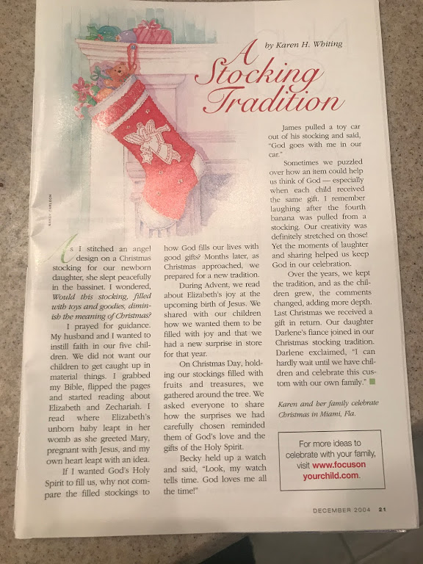
For a large family, you might want to simply pull out a few items for this tradition and not continue until every stocking is emptied. If there’s lots of time and your family is small, enjoy comparing every treasure.
Taking time with stocking slows down the rush of diving into presents and running off to play. It allows a family to cherish time together while focusing on how God the Father, Jesus, and the Holy Spirit impact our lives.

Christmas Traditions for Family Bonding BY Karen Whiting
Link: https://www.crosswalk.com/special-coverage/christmas-and-advent/10-best-christmas-traditions-for-family-bonding.html
Christmas comes around once a year, so we want to make the most of the season. Meaningful Christmas activities help us prepare our hearts and focus on the reason we celebrate. Traditions build a sense of belonging and family identity. Starting a tradition helps grow family bonds and create lasting memories. Try some of these activities that can become annual favorites.
Photo courtesy: ©Thinkstock/LuckyBusiness

1. Treasure the nativity story.
Christmas celebrates the birth of Christ and fulfillment of many prophecies. We should treasure the biblical story and read it at the beginning of the season. We can also weave the reading into our Christmas Eve and Christmas Day festivities.
Take time to reflect over the story as told in Luke 1-2 and Matthew 2. Look up some of the prophecies such as Micah 5:2, Isaiah 7:14, and 9:7.
Focus on Christ by reading a few verses each day from these accounts and dwell on the words. Find a carol that focuses on the part of he story read, to rejoice in that aspect, such as O Little Town of Bethlehem when studying the journey of Mary and Joseph.
Photo courtesy: ©Thinkstock/mastapiece
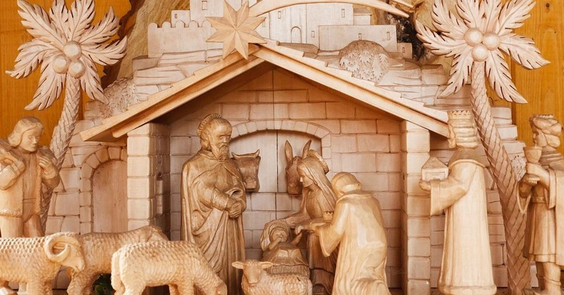

2. Play out the birth of Christ with a nativity set.
A nativity set depicts the events of the birth of Christ. Help families picture the event by placing the figures away from the manger and moving them each day as a reminder of the journey each person took to Bethlehem.
Use an unbreakable nativity set for children to retell the story or hold up figures as the story is read.
Giftwrap the figure of Jesus and wait until Christmas to unwrap him. It’s a good way to recall that God sent Jesus to us as a precious gift.
If you have a large manger and baby Jesus that is separate you can add straw each day for good deeds family members did to make a soft bed for Jesus.
Photo courtesy: ©Pixabay/PublicDomainPictures

3. Celebrate the Light of the World.
Jesus is the light of the world and all the bright lights should be reminders of that. If you use a tree, read Hosea 14:8 where God describes himself as an evergreen tree and then add the lights.
Take a stroll or drive through a neighborhood that’s lit up and rejoice when you see symbols of Christ and nativity sets.
Go shopping at the mall to see lights. Look for signs of Christmas related to Jesus. Here’s a list of decorations to find. Add to it as you see other reminders of Christmas.
- Christmas lights (Jesus is the light of the world - John 8:12)
- Christmas trees (We are part of God’s family tree - Hosea 14:8b)
- Nativity set (Jesus came - Luke 2:1-7)
- Candy canes - Shepherd’s staffs (Shepherds worshipped Jesus - Luke 2:8-20)
- People expressing thanks (God wants us to be thankful - 1 Thessalonians 5:18 )
- Star decorations (The wise men followed a star - Matthew 2:9)
- People from many nationalities (Jesus came to save everyone - John 3:16)
- Wreath - circle of greens (God’s love is like a circle-eternal - 1 John 4:7-8)
- Angels (God’s messengers - Luke 2:9-12)
- Dove (Sign of the Holy Spirit - Matthew 3:16)
- Sheep (We are God’s sheep - Luke 2:8)
- Snowflakes (God washes our sins white as snow - Isaiah 1:18)
- Crown (Jesus is our king - Matthew 2:2)
- Gold, incense, or myrrh (Gifts given Jesus - Matthew 2:11)
- Carolers (Singing praises God - Isaiah 30:29)
Photo courtesy: Unsplash.com
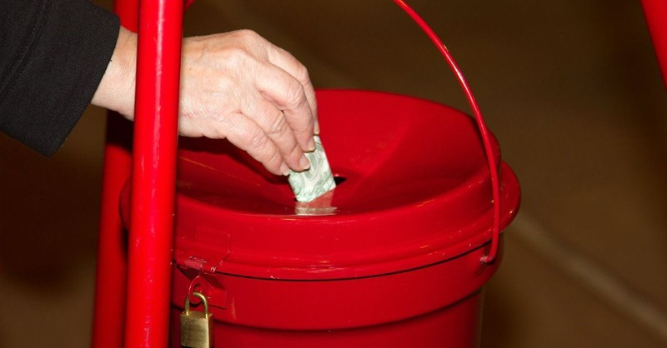

4. Be extra generous.
Choose to be extra loving and giving at Christmas. Some families make sure to draw names of needy children to buy clothes and toys for them. Make that special by adding little notes and mini-gifts in pockets of clothes or with the toy.
Bring cheer to neighbors. Bake cookies or Christmas bread to pass out to people on your street. Add a card with a note thanking them for being your neighbor.
Be generous as you shop. Let someone go ahead of you in line and smile at the clerks and thank them for taking care of your purchases.
Buy some gift cards, even ones with small amounts on them, to give someone needy or stressed.
Photo courtesy: ©Thinkstock/casch

5. Focus daily with Advent devotionals.
Advent comprises the four Sundays before Christmas and the days of those weeks. Put up an advent wreath with candles. Spend a short time daily lighting the appropriate candles and sharing a devotional. Each candle has a name and theme word to help focus on Jesus.
Week 1. Prophecy Candle, Hope
Week 2. Bethlehem Candle, Peace
Week 3. Shepherd Candle, Joy
Week 4. Angel Candle, Love
Use the names and words as your focus of the week to reflect on various aspects of the season.
For week 1, look up Scriptures of prophecies about the birth of Jesus and find how they were fulfilled. Consider projects that will bring hope to people, such as making tray favors for a nursing home.
Week 2, chat about how Bethlehem means house of bread and that Jesus is the Bread of Life. Make bread. Work on peace at home without complaining or arguing. Be polite and let others have first choice.
During Week 3, pass out candy canes for shepherd staffs. Sprinkle joy into one another’s day with smiles and words of encouragement.
For Week 4, show love with a group hug. Discuss the role of angels at the birth of Christ.
On Christmas day add a white candle in the center for the Christ candle. Sing Happy Birthday to Jesus.
Photo courtesy: ©Unsplash/AaronBurden

6. Fill the air with praise.
Turn on Christmas music and speak encouraging words to fill the air with joy. Say “Have a Blessed Christmas” or “Merry Christmas” often. Attend a Christmas musical or play or join with others to carol.
Talk about what it means to rejoice and why we should celebrate at Christmas. Have a praise evening or praise time while driving in the car. Let each person shout out a reason to praise God.
Photo courtesy: ©Thinkstock/olesiabilkei

7. Enjoy family time.
God brought Mary, Joseph, and even shepherds who they did not know, together at the birth of Christ. Rejoice with others. Be sure to attend a church service. Enjoy a few Christmas gatherings and plan to spend Christmas Eve or Day with loved ones. Invite people who might not have family nearby to celebrate with you.
Spend some of the season relaxing. Plan a time to watch favorite movies, exchange gifts, or simply share a meal. Use the time to bless each person with your undivided attention.
Photo courtesy: ©Thinkstock/jacoblund

8. Spend time blessing others.
Reach out to share the good news. Send Christmas cards or a Christmas letter that shares your blessings received and struggles during times you trusted God through the year.
- Think of a way to reach out that you might want to repeat every year.
- Volunteer to help at a shelter or with a toy drive
- Choose to watch a single parent’s children so he or she can shop.
- Consider God’s little critters too and put out extra food or decorate a tree with bird treats.
- Purchase some gifts that are made by people in poor areas such as Appalachia or a third world country.
- Chose to give up desserts or snack for a week and send the money saved in a significant way, such as donating it to to an organization that helps needy people or to purchase a gift for a toy collection.
Photo courtesy: ©Thinkstock/Ulza

9. Unwrap the gift of Christmas daily.
Let each day be a day to rejoice. Collect books, CDs, and DVDS that you own and wrap them individually. Place them in a basket or other container. Count how many you have and start that many days before Christmas opening and enjoying one each day whether it lasts one week twenty-five days. This can become a favorite tradition for little ones that helps them be patient as they wait for Christmas Day.
Stack the wrapped packages to form a little Christmas tree and decorate it with some garland or a sting of lights. Set aside a little time to read the book or watch the movie. Each day talk about how the gift opened reminded them of the reason we celebrate.
Photo courtesy: ©Thinkstock/filipefrazao

10. Serve one another.
Christmas is a season to bless others. Performing kind deeds is one way to express love and share the love of Christ. Let your family choose to serve one another a little more during this season. A back rub for a family member, doing someone’s chores, or making and serving a special treat are all ways to serve.
You can also draw names to be a secret angel to someone in your family. Spread your wings to sprinkle joy in their days before Christmas with little notes, deeds, and tiny gifts like a candy or sticker. Set a time to reveal the identities of the angels.
Be more thoughtful with thanking family members for what they do to make life happy. Spot ways to help before being asked.
Any activity that brings family members closer strengthens family bonds. The activities you start repeating every year become your family traditions and part of your heritage to pass on to future generations.
Karen Whiting is an author of 25 books, an international speaker, and former television host. She’s a mother of five and a grandmother. Her book 52 Devotions for Busy Families makes it easy to practice faith at home. Connect with her on Facebook, Twitter, and Pinterest.

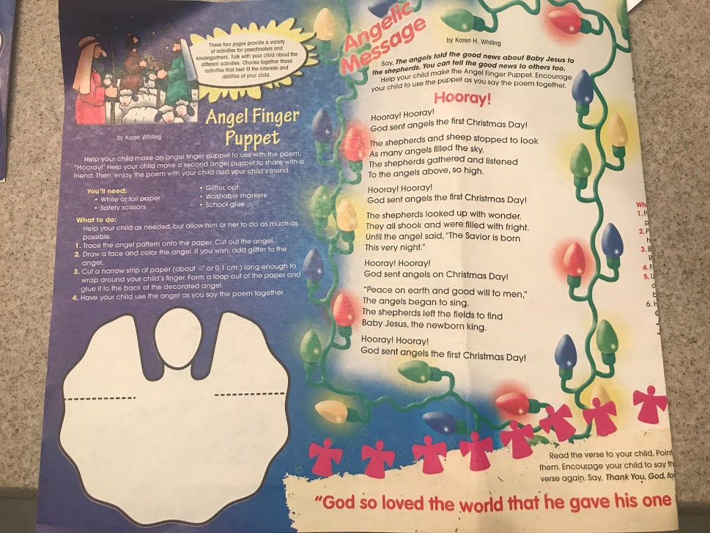
Keep Christ in Christmas this year!!
By Karen Whiting

Simple ways to focus on Jesus. Choose different ones each year.

When shopping…
- Find Christian symbols displayed and how they relate to Jesus, from lights, bells and star decorations to nativity sets being sold. See who can find the most!
- Look for gift-wrap that reflects the meaning of the season to encourage more merchants to sell more Christian paper. Or stamp your own wrap!
- Pass on God’s love, even if it is simply to say, “Have a Blessed Christmas.”
Before Christmas…
- Make room for the light of the world-Jesus! Light an advent wreath and use the time to sing Christian carols and read prophecies about Jesus.
- Make room in your budget. Shop for baby clothes for Jesus. Pick out what you would really want him to wear. Then wrap it up and give it to a homeless shelter.
- Choose a giving project, such as toys for the needy. Involve the family in buying the gifts. Add a special love note with each gift telling others about God’s love.
- Reach out to neighbors. Make plates of cookies or buy and give out candy canes. Add Christmas cards and a brief message that tells why you have room for Jesus.
- Think of ways to express love for Jesus, such as doing someone else’s chores.
- Make a paper chain of love deeds. For each person’s daily deeds that expressed love, add a paper link. On Christmas Eve, wrap the chain around the tree to wrap the tree in love.
- Read the Christmas story a few times. Talk about the events and people.
- Invite Jesus in: Have everyone make heart decorations to decorate their bedroom doors. Let each person write or draw a message inviting Jesus to be with him/her always! Cut a door opening in the heart and place a picture of Jesus inside the door.
Christmas Day….
- Sing Happy Birthday to Jesus. Give thanks to God for the gift of life, eternal life.
- As you open stockings, relate items to being filled with God’s love or gifts of the Holy Spirit.
De-stress
- Take five minutes breaks throughout each day to relax and thank God for coming.
- Give out hugs. Hug yourself. Hugs calm you and get others in the mood to help.
- Delegate tasks to family and guests.
- Identify, pray about stressors, eliminate some. Reflect on what brings joy.
- Eat healthy, rest, listen to carols, and laugh.
Still gift hunting or wrapping?
- Wrap a picture or a promise note instead. Add a note that the greatest gift is Christ.
- Pop gifts in pillowcases.
Christmas cards not signed and sent?
- Send Valentines or Easter cards instead with a message of God’s love
Over-scheduled?
- Say no to some events or just pop in for five minutes. Choose joy over stress!

